**Project Title: Project Design Phase-I** - **Solution Fit Template Team ID: PNT2022TMID11798**

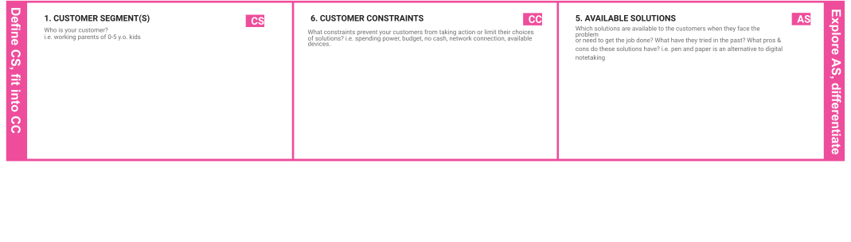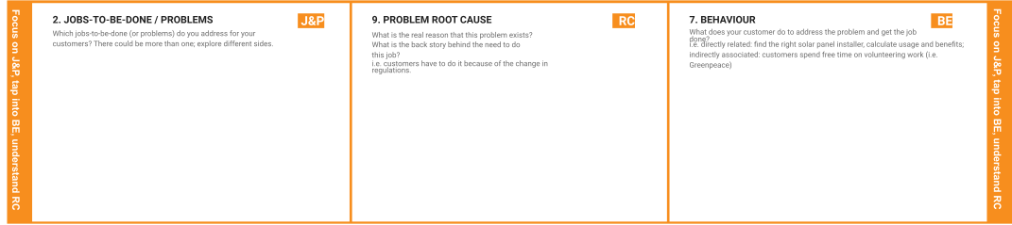

Our customers are ordinary people because, in today's world, everyone needs to know the quality of the water they drink, and we primarily target people over the age of 18 because they are well-versed in the technologies we use.

Customers' main concerns are network availability and device availability, and the time required to receive daily updates may be prohibitively expensive for some. The resources, both financial and human, are insufficient.

* Water temperature can be monitored.
* The PH level of the water is determined.
* The amount of oxygen that is dissolved in water.

People in society had to know the quality of water; however, traditional methods make it impossible to inform people, which causes many problems such as disease. We use new technologies and trends to make people aware. This project encourages more graduates to work on it.

The arrival of this project is due to the need to keep and monitor the water used for various purposes, particularly drinking. We took on this project in order to make the most significant change in society and dispel the myth of technology utilisation.

Direct Relation: Improve network accessibility and determine the quantity and quality of water

Indirect Relation: free customer spending time educating people about the system to other people.

|  |  |  |  |  |  |
| --- | --- | --- | --- | --- | --- |
|  | **3. TRIGGERS TR** | | **10. YOUR SOLUTION SL**   * We provide a good source to the public and base our work on public feedback. * The PH level of the water is determined. * The turbidity of the water is determined. * Water conductivity is determined. * The temperature of the water is constantly monitored. * A monthly report on water maintenance will be displayed. | **8. CHANNELS of BEHAVIOUR CH**  **ONLINE :**   * Public may provide review and rating for the system. * The software used should be properly studied by everyone to operate it. * The software and hardware connections should be given properly.   **OFFLINE :**   * Public funds should be provided to develop the system and enable it to move forward; and the hardware setup should be properly installed. |  |
| * By implementing this project, we can pique people's interest by seeing their neighbour use technology more effectively and reading about a more efficient solution in the news. * If the mobile app is not used, someone should always be present to maintain the parameters, and the maintenance cost should be paid. |  |
|  | |
| **4. EMOTIONS: BEFORE / AFTER**  **BEFORE : EM**   * Prior to the implementation of this project, people found it difficult to enjoy boating, fishing, and the provision of safe drinking water. * They also face significant challenges in developing industrial, hydroelectric, and agricultural water requirements. **AFTER :** * After implementing this project, people will be able to easily deal with all of the aforementioned issues. | |



|  |  |  |  |  |
| --- | --- | --- | --- | --- |
|  |  |  |  |  |